Rapport CIBiG
SORY Siédou – 21 avril 2026

Introduction
The genus Dioscorea comprises over 600 species distributed across the tropical and subtropical regions of Africa, Asia, Oceania, and the Americas, but only about ten species are domesticated and cultivated for food purposes (Coursey, 1967; Lebot, 2020). Among these, Dioscorea rotundata is the most important yam species in West Africa. It represents an essential resource for food security and plays a central role in rural economies and sociocultural systems, particularly in Nigeria, Benin, Ghana, Côte d’Ivoire, and Burkina Faso (Hahn et al., 1987; Lebot, 2020). In Burkina Faso, Dioscorea rotundata is mainly cultivated in the Sudanian and Sudano-Sahelian zones, characterised by high climatic variability and short rainy seasons, which makes adaptation to water stress particularly important for agricultural productivity (Dansi et al., 2013).
Several studies have analysed the genetic diversity of yams in West Africa using molecular markers such as microsatellites (SSR), AFLP, and chloroplast markers. These works have highlighted a high genetic diversity as well as gene flow between cultivated and wild forms, suggesting a complex domestication history (Mignouna et al., 2002; Scarcelli et al., 2006). However, these approaches were limited by the small number of markers used.
Scarcelli et al. (2019) made a significant advance by analysing 167 accessions of Dioscorea rotundata through whole genome sequencing. Their study identified over 66 million SNPs, of which approximately 3.57 million were high quality after filtering, highlighting substantial genetic structuring and gene flow within West African populations.
However, the accessions from Burkina Faso were not included in this analysis. Consequently, their genetic diversity and their position within the West African context remain poorly characterised.
The integration of these accessions into large-scale genomic analyses is therefore essential to better understand the genetic diversity of yam, improve varietal selection programmes, and study the mechanisms of adaptation to environmental constraints.
Objectif scientifique
The scientific objective of this study is to incorporate six new yam accessions from Burkina Faso in order to determine their position within the genetic diversity of yam in West Africa as described by Scarcelli et al. (2019). The aim is to assess their membership to existing genetic groups and to better understand their integration into the regional genetic pool of Dioscorea rotundata.

Bioinformatics objective
The bioinformatics objective is to test a new SNP calling pipeline and compare it to the workflow used by Scarcelli et al. (2019). This comparison is carried out using two different versions of the reference genome (TDr96x99_v1.0 and TDr96_F1_v2), in order to assess the impact of the choice of reference and analysis parameters on variant detection and genetic structure results.
Mind map
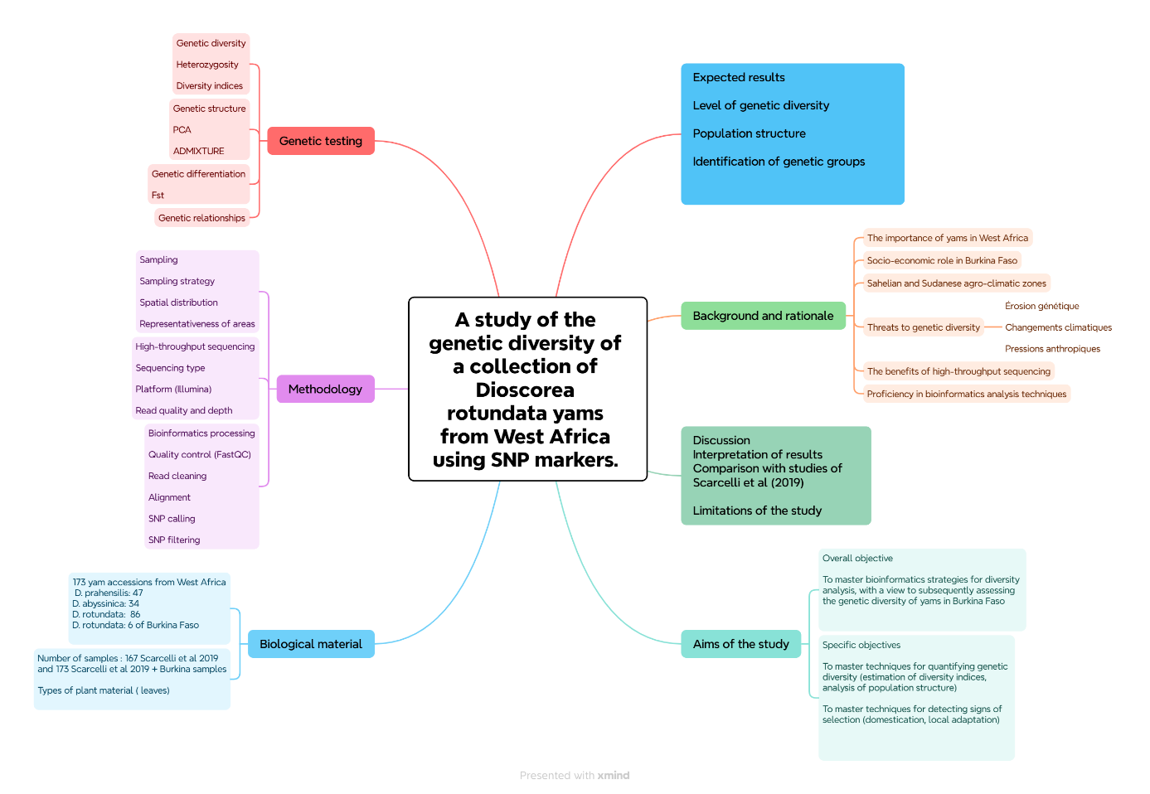

- Project workflows
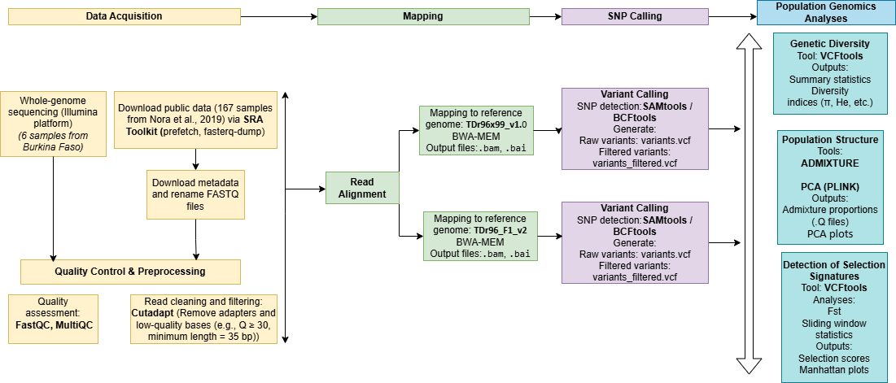

- Biological material
The dataset used combines two sources: a reference set of 167 accessions published by Scarcelli et al. (2019) and six new accessions collected in Burkina Faso. This integration allows for the analysis of Burkinabé accessions within a broader regional context.
- Sequencing strategy
Genomic DNA was extracted from young yam leaves at IRD. The sequencing, carried out by whole genome sequencing on an Illumina platform, produced a large volume of short sequences.

- Bioinformatics processing
✓ Data pre-processing
The data include the new sequences from Burkina Faso and the public data from Scarcelli et al. (2019).
The following steps were carried out:
• Initial quality control (base quality, GC content, adapters);
• Merging of lanes for the Burkina Faso sequences;
• Second quality control on the Burkina Faso sequences after lane merging;
• Harmonisation of identifiers via metadata.

✓ Sequence alignment
The sequences were aligned to the reference genome of Dioscorea rotundata using BWA, then sorted and indexed with samtools.
Two reference genomes were used:
• TDr96x99_v1.0 (V1): based on the data from Scarcelli et al. 2019
• TDr96_F1_v2 (V2): based on the data from Scarcelli et al. 2019 + 6 samples from Burkina Faso
This approach allows assessment of the reference genome's effect on the results. Time did not permit us to perform mapping and SNP calling with V1 on the data from Scarcelli et al. 2019, plus 6 samples from Burkina Faso, and with V2 on the data from Scarcelli et al. 2019.

- ✓ Detection of variants
The SNPs were identified with bcftools, through joint calling on all samples. The VCF files were then indexed.
- ✓ SNP filtering
- The following criteria have been applied:
- removal of variants: of low quality (QUAL), poorly aligned (MQ), with too few or too many reads (DP)
- retention of only biallelic SNPs;
- removal of indels and multiallelic sites;
- exclusion of variants with more than 25% missing data.

- Analyses
The analyses performed include:
- Principal Component Analysis (PCA);
- Population structure analysis (ADMIXTURE).
The optimal number of genetic clusters (K) was determined using cross-validation in ADMIXTURE.

6. Results
6.1. SNP calling – Reference genome V1 (TDr96x99_v1.0) on Scarcelli et al. (2019) data
Using the 167 individuals from Scarcelli et al. (2019), we obtained the same number of individuals after SNP calling and filtering. The variant summary is as follows:
- 59,742,697 total variants
- 57,996,774 SNPs
- 1,745,923 indels
- 4,852,867 multiallelic sites
After filtering:
- 21,694,953 SNPs
This represents a substantial reduction due to filtering, while still retaining a high level of genetic diversity.

6.2. Comparison with Scarcelli et al. (2019)
- Scarcelli et al.: ~3.57 million filtered SNPs
- This study: ~21.7 million SNPs
This difference may be explained by the bioinformatics tools and software versions used. In this study, SNP calling was performed using bcftools, whereas Scarcelli et al. (2019) used GATK. More recent pipelines, particularly those based on bcftools, often detect a higher number of variants but require stringent filtering to avoid introducing noise.
The choice of reference genome may also play a role. Although the same reference (TDr96x99_v1.0) was used, differences in versions, annotations, or alignment parameters can affect variant detection.
Despite these differences:
- PCA reveals a structure consistent with that reported by Scarcelli et al. (2019);
- the major genetic clusters are preserved.

6.3. SNP calling – Reference genome V2 (TDr96_F1_v2) on combined data (Scarcelli et al. 2019 + Burkina Faso)
Variant calling performed on the combined dataset (Africrop + Burkina Faso accessions), using the reference genome TDr96_F1_v2, identified a total of 80,608,389 variants across 173 individuals. The variant summary is as follows:
- 80,608,389 total variants
- 76,050,235 SNPs
- 5,769,985 indels
- 7,774,349 multiallelic sites
After filtering:
- 608,741 SNPs
The increase in the total number of variants compared to the Africrop-only analysis (V1) can be explained by the inclusion of new Burkina Faso accessions, as well as the use of a different reference genome, which may better capture certain genetic variations.
The drastic reduction in variant number, from over 80 million to approximately 608,000 SNPs, highlights the impact of the reference genome used and the nature of the dataset analyzed (Africrop alone vs. Africrop + Burkina Faso).
Compared to the results obtained with reference genome V1, the final number of SNPs is much lower, which may suggest higher specificity of the V2 reference genome.

6.4. Genetic structure and position of Burkina Faso accessions
Population structure analyses, particularly PCA, show that the Burkina Faso accessions cluster with other Dioscorea rotundata accessions.
This clearly indicates that:
- Burkina Faso accessions belong to the main genetic pool of Dioscorea rotundata;
- they do not form a strongly differentiated genetic group;
- they are genetically close to other West African accessions.
This observation is consistent with results obtained using V1 as well as with those reported by Scarcelli et al. (2019), and suggests strong genetic connectivity among yam populations in West Africa.
The integration of Burkina Faso accessions into existing genetic groups may be explained by:
- exchange of planting material between regions;
- traditional farming practices promoting variety diffusion;
- a shared domestication history.
This result is particularly important, as it confirms that Burkina Faso accessions can be integrated into regional breeding programs without major genetic barriers.

Conclusion
This study confirms that:
- Burkina Faso accessions belong to the main genetic pool of Dioscorea rotundata;
- West African genetic structure is stable and robust;
- methodological choices strongly influence genomic results.
It also highlights the importance of:
- harmonizing bioinformatics pipelines;
- adapting filtering strategies to study objectives;
- integrating new accessions to enrich genetic diversity.
Burkina Faso accessions can therefore be fully integrated into regional yam breeding programs.

